Our aim is to become a plain language writer means write in easily understandable format

Active voice- I love my subscribers --> subject+ action + object

Passive voice- subscribers will be loved by me --> object+ action (v3) + subject

Active voice --> you should submit the documentation (sub+act+obj)

Passive voice -> documentation must be submitted by user

# Tips to send emails

1. Always write emails in plain language- which should be easily understandable by all people
2. Always keep question mark when u are asking question in your email

1) Use bullets

1.1) or use Tables

2) Use numbered lists

3) Use groups, Sub groups

4) Avoid writing paragraphs

5) Use headings to highlight message-

3) First write all what related words... is this... what is metro.. and then write about "why"

ex:- what is corona?......some 10 pages (so always write about "what" related info )

Why corona will come...(then write about "why" related information??)

4) Write summary first --> Readers should understand mail by reading first 2 lines itself- because they don’t have patience to read entire mail

Begin with main point or summary- Put the bottom line upfront- understand the readers question first

they should understand the entire mail within 2-3 minutes, most readers want to understand the bottom line first

so first keep the main point first

use case :- in ur mails, nobody will have patience to read entire mail, so write summary first

ex:- heading is -how to quit smoking, but if u answered that last its not good, just for this point all people should not wait , so keep main point 1st

ex2:- mainly people will come for sarees , so south india shopping mall guys keeps the sarees section last

5) Readers won’t read the entire document

6)

7) Always write in active voice- means the sentence must be in present tense and starts with subject (i or we?)- To easily understand

8) Avoid this and that habbit, write only one --> children with serious (this) and noticeable (that) vision, instead u can use below

Children with serious vision here we wrote only this

9) avoid technical jargons in mail which readers cant understand - before sending always check if that customer can understand that mails or not.

10) While using abbreviation in the current mail u should write fully without shortcuts, later u can use

11) Use prepositions & use un-smothered verbs-

|  |  |
| --- | --- |
| Prefer | Not recommended |
| the committee met to discuss the draft regulations to improve protection for immigrant tenant rights (here we have used more prepositions) | the committee met to discuss the draft immigrant tenant rights regulations |
| we suggest the model 34 camera a product that will fit your needs | our suggestion for a product that will fit ur need is the model 34 camera  (here we used smothered verb )  Indications of smothered verb, (avoid all these below)   1. -ance 2. –ence (use prefer instead of preference) 3. –mant 4. –ment(use agree instead of agreement) 5. –sion 6. –tion (suggestion, use inform instead of information) |
|  |  |

## Responding to emails

1. Say Thank u for your email, responding to our..
2. Paraphrase or rephrase customer problem🡪Acknowledge the customer feeling🡪 **Customer should feel that we understood his problem** and we are caring for him

Ex:- we are very sorry, and we understood that when u are trying to book ticket ur money is debit but u didn’t get ticket..

And we understand how frustrating it is u hoped a beautiful night, but unfortunately this happened

I deeply regret to inform u that u didn’t receive the ticket after booking train

1. Answer the customer question(solve the problem) and u should anticipate the follow up question , if u don’t anticipate the follow up question customer will write another email

Ex:- if a customer didn’t get the refund for a cancelled ticket

Your response:- Thank u for contacting us, we are very sorry as u are waiting to receive the refund since 5 days…

Your response:- Thank u for contacting us about the refund problems..

Your response:- Thank u for writing to us, I can understand why u are frustrated, about our online payment system…

1. Anticipate customer question with these, whereas basic customer questions start with – who, what, when, where, why, how, can I , can you

Like give him all details and prevent him sending the follow up emails

Ex:- we have received ur defective watch, we are already verified it , (we should tell him when he will get refund) you will get refund by 12th to ur original payment mode

Ex2 , so we should anticipate this and tell the customer mail id

|  |  |
| --- | --- |
| (incomplete way) For immigration service contact isms team,  (here some details are missing, the exact mail id whom to contact,  So if u just say like this then customer will send a mail again for mail id) | (Right way is to include all details by anticipating customer questions& say as below)  For immigration service u should contact isms team using mail id ([Ismsservices@tcs.com](mailto:Ismsservices@tcs.com))  If u send all necessary details we can avoid a follow up mail from customer |

1. No, But <your reason> <work around>is the good way ex:- No, we are not going to refund, but we will ensure this will not happen again
2. Because <the reason>, and<what u will do> keywords, use because to tell the reason ex:- ur order is late, because the jacket is out of stock and we are going to refund shipping charges
3. Respond and acknowledge the customer feeling without agreeing customer feeling– customer should feel u read his email and u are also feeling bad about it

|  |  |
| --- | --- |
| Customer – Dirty toilets in ur hotel | You- we are very sorry about ur un pleasant experience with cleanliness issue with our hotel… |
| Customer- worst coffee mug not at all keeping warm | I am very sorry that u are disappointed with our travel mug, but to keep warm….(this shows we understood their feeling and we are not accepting the problem also we are showing the solution) |

1. Use the words like “I” instead of “our records” show, because it indicates customer that u are owning and feeling his problem

|  |  |
| --- | --- |
| Worst way (our records show u missed d payment)  because here u are not owning the problem | Good way- I checked our records and I came to know u missed the payment |

1. When u did wrong, u should say sorry sincerely

Ex:- we are really sorry for this loss and <explain why it happened> & <explain the fix> & <explain what customer can do if this happens again>

Ex:- just saying one word “sorry” is really bad

|  |  |
| --- | --- |
| Personal (preferred) | Impersonal |
| I am sorry for | We regret any inconvenience (not good any incov.. means u should be specific) |

1. Show empathy (ability to understand other person feeling)

ex:- I am very sorry I deeply apologise for the loss of your money but don’t worry we are here to resolve ur issue

1. Don’t write the emails abruptly, write in assertive way & write in smooth way, don’t use harsh words,

State the reason for action-provide an understanding of the situation ex:- as the customer is coming tomm, complete coding today

Present common goals-indicate the need for collaboration

State benefits-present a win-win situation

Extend courtesy-motivate positive response

. Indicate timelines and action required-finally, move to action.

To orchestrate a quick and enthusiastic response, all you need is a touch of persuasion

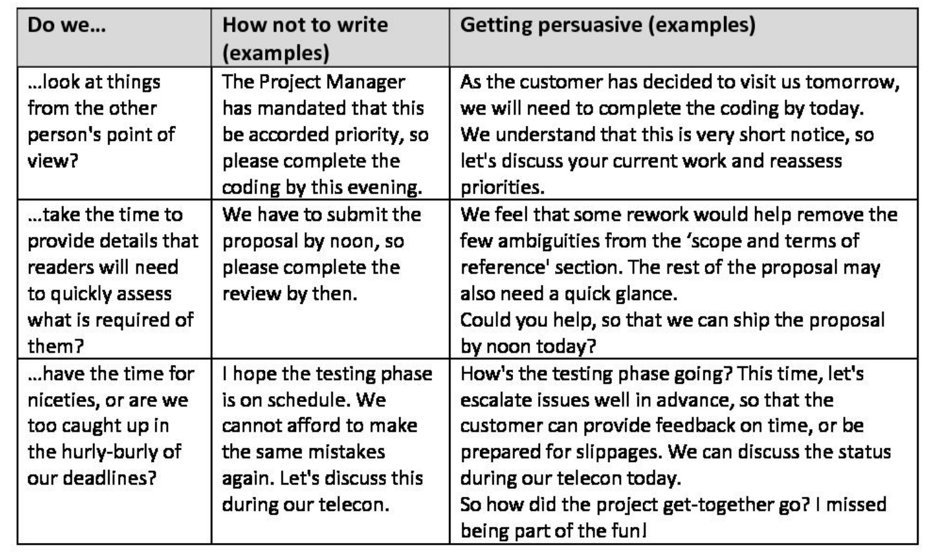

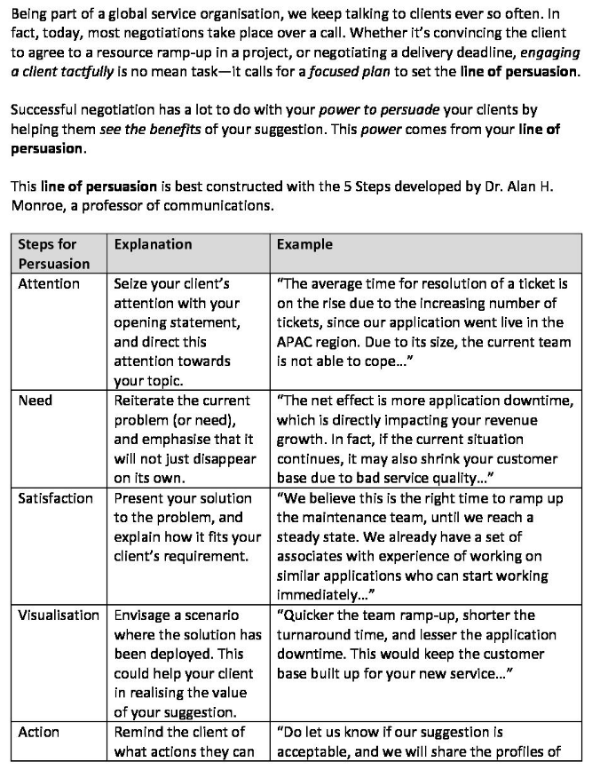

## Apologies

Hi sriram,

Apologies for not responding you earlier